PROJECT TITLE: TRACING THE GROWTH OF THE GLOBAL COMMUNITY:A POIPULATION FORECASTING ANALYSIS

# INDEX

|  |  |
| --- | --- |
| S.  NO. | CONTENTS |
| 1. | Introduction   * 1. Overview   2. Purpose |
| 2. | Problem definition and Design thinking   * 1. Empathy map   2.2 **Ideation and Brainstorming map** |
| 3. | Result   * 1. Worksheets, dashboard and story |
| 4. | Advantages and disadvantages of the project |
| 5. | Applications |
| 6. | Conclusion |
| 7. | Future scope |

1. Introduction:

# 1.1 Overview

This method involves discovery of factors that influence present and past population increase and decrease. On the assumptions concerning the future of these factors and of other factors that or just emerging in the community,projections of fertility, mortality and migration trends are made.

# 1.2 Purpose

A population projection gives a picture of what the future size and structure of the population by sex and age might look like.

It is based on knowledge of the past trends, and for the future,on assumptions made for three components,fertility,mortality and migration.

# Problem definition and design thinking:

2.1 Empathy map

**Brain stroming**:

1. Result:

# 3.1 Worksheets, dashboard and story

Below are the seven worksheets from TABLEAU representing the following activities: 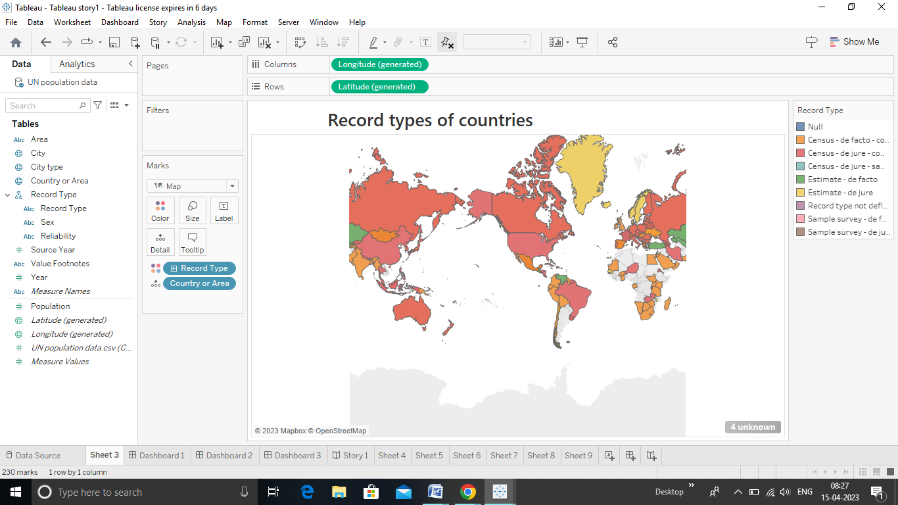

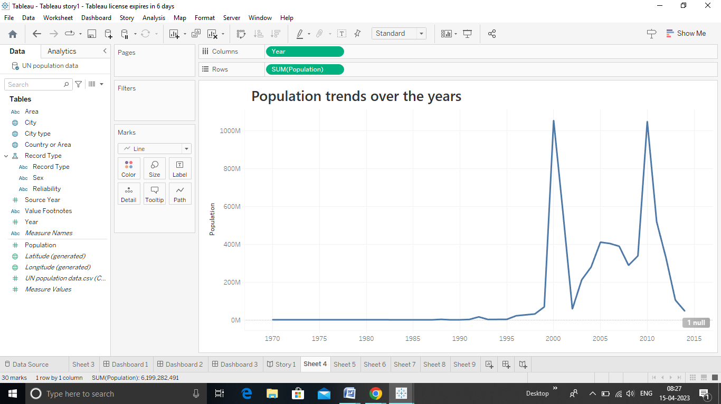

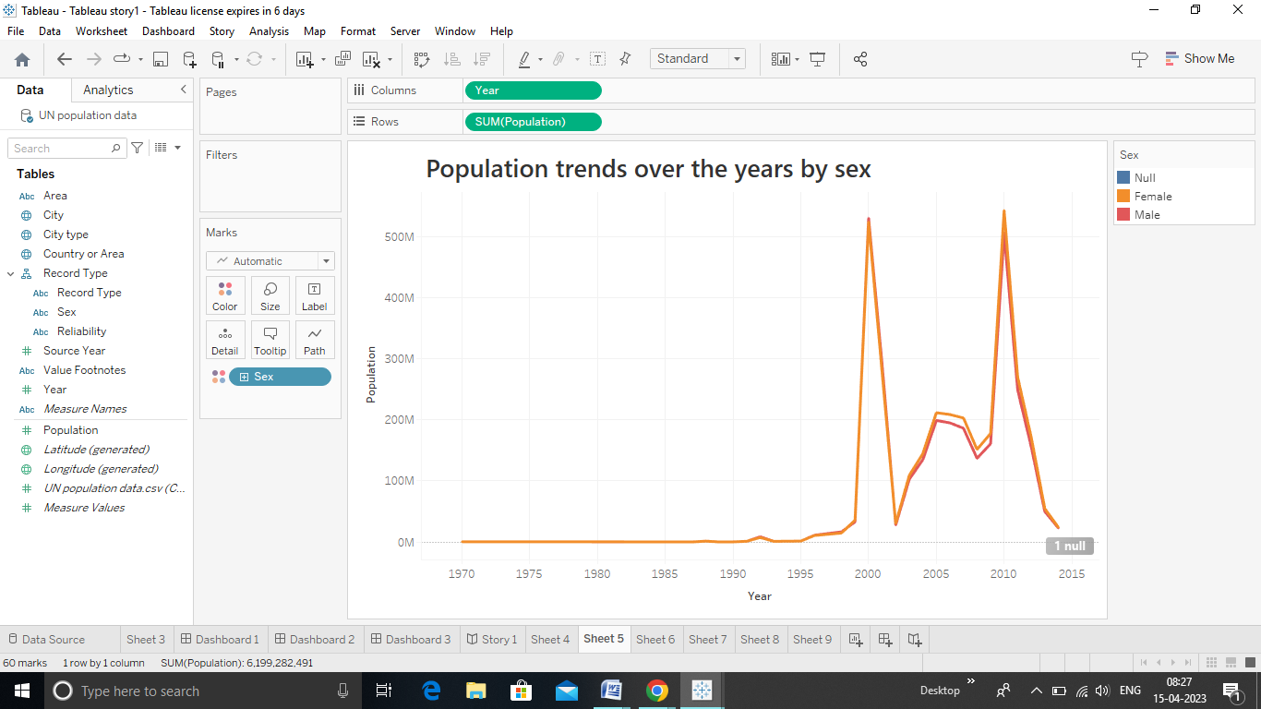

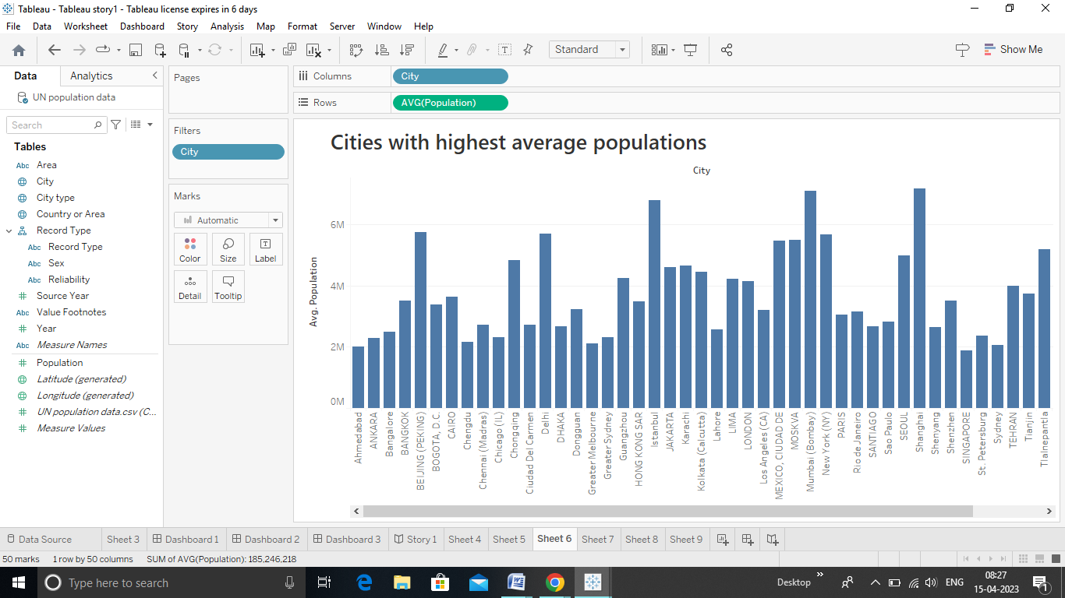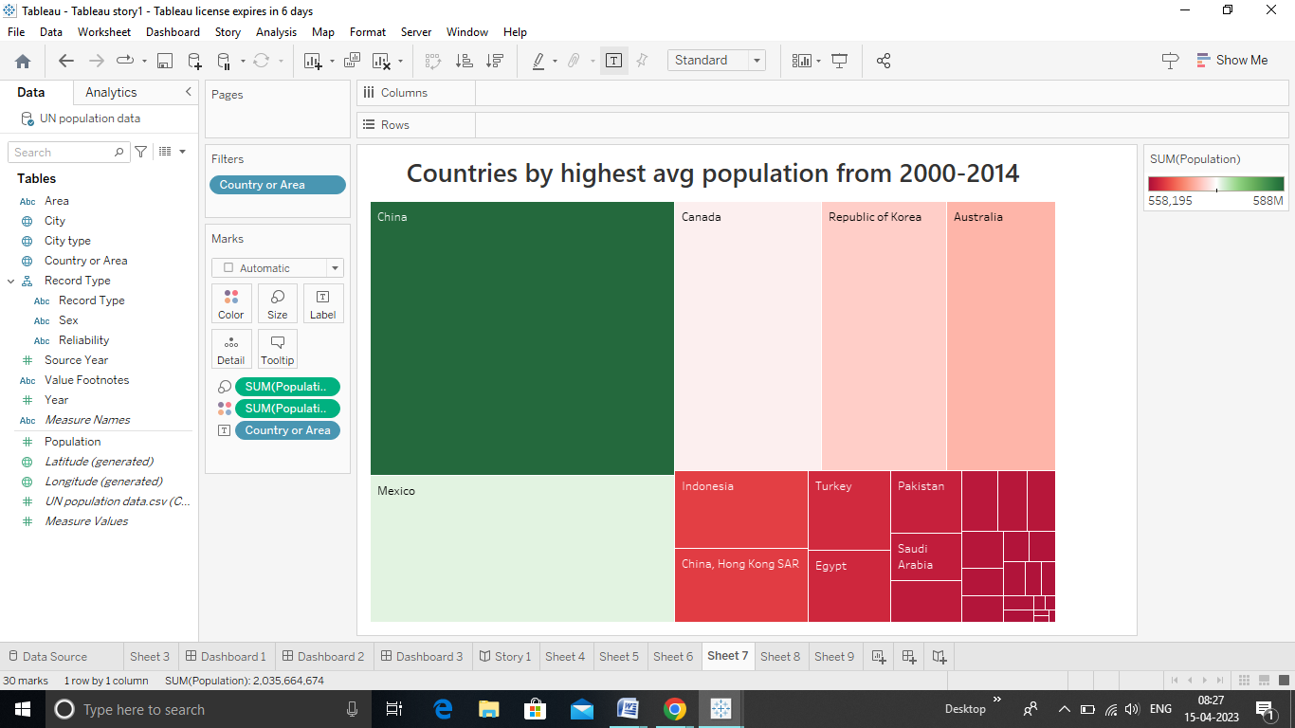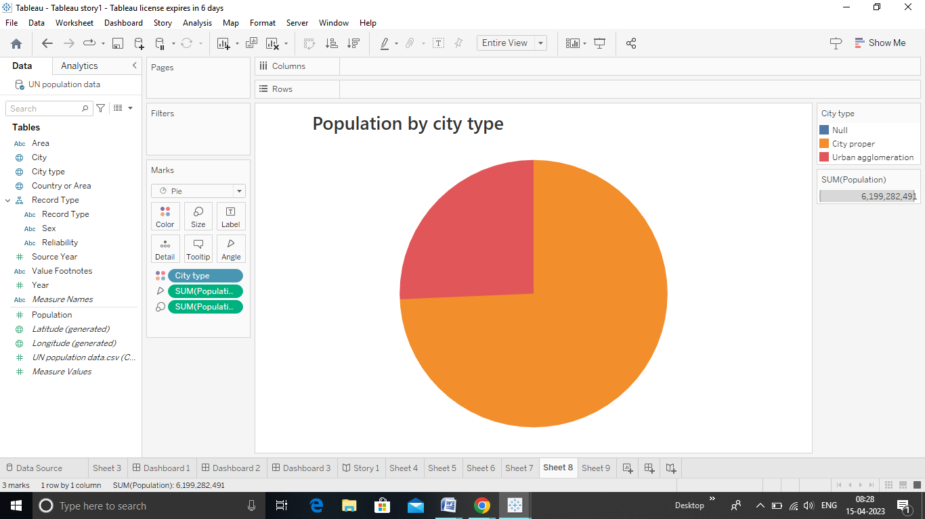

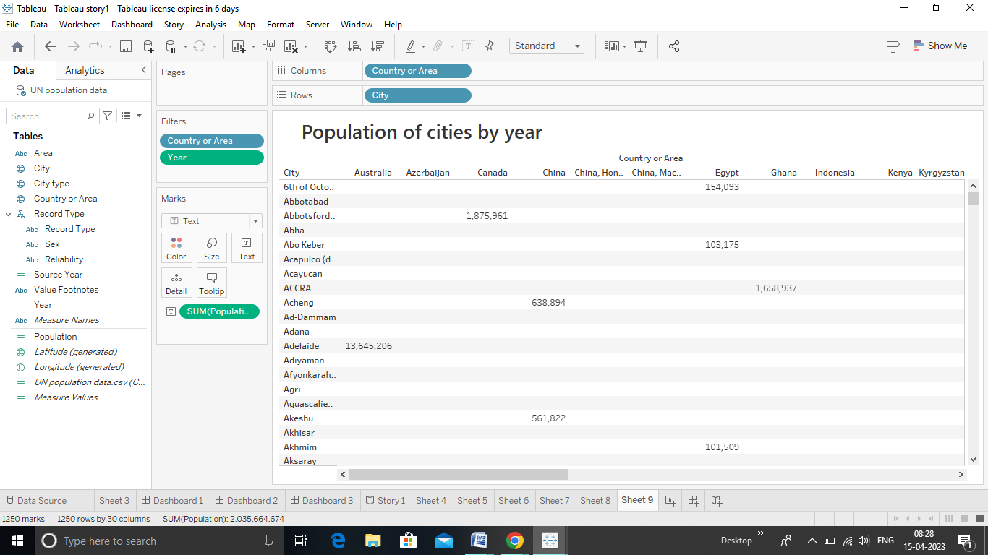

# Dashboards:

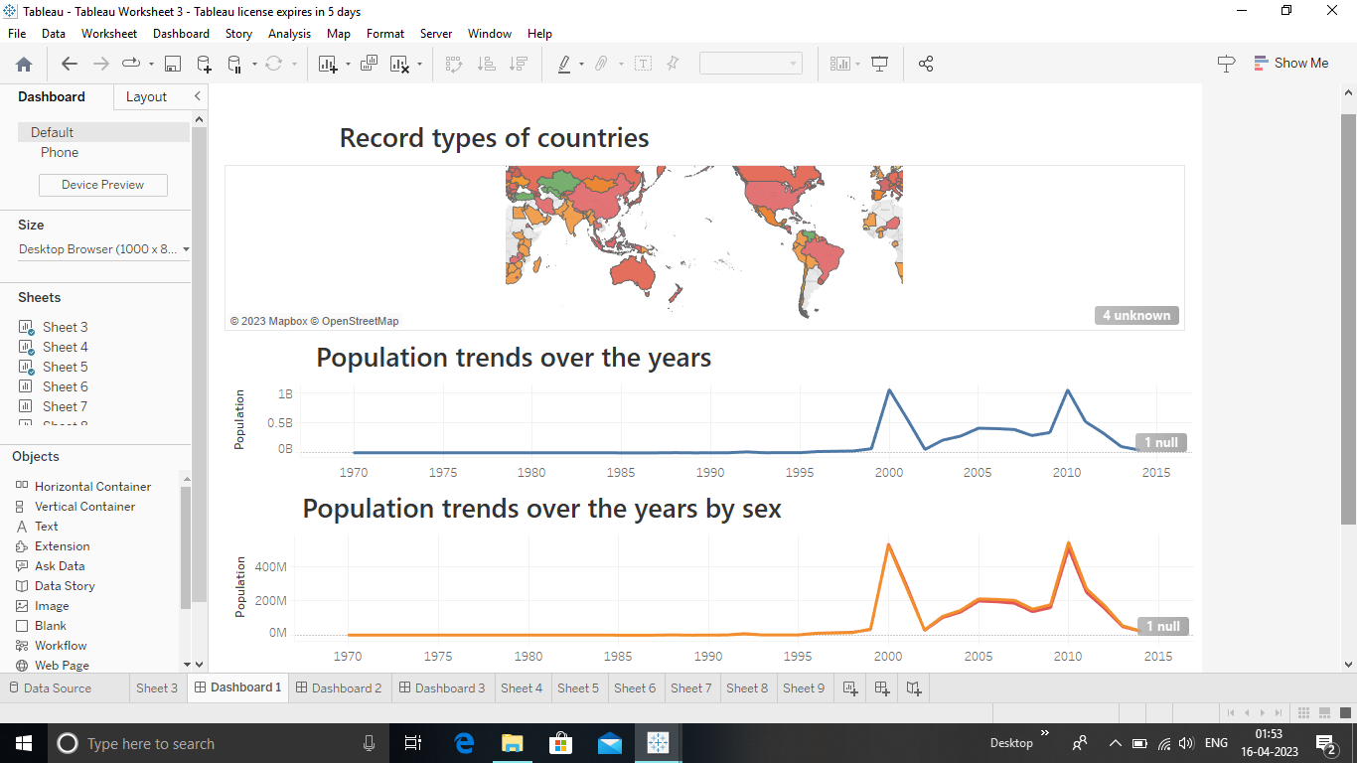

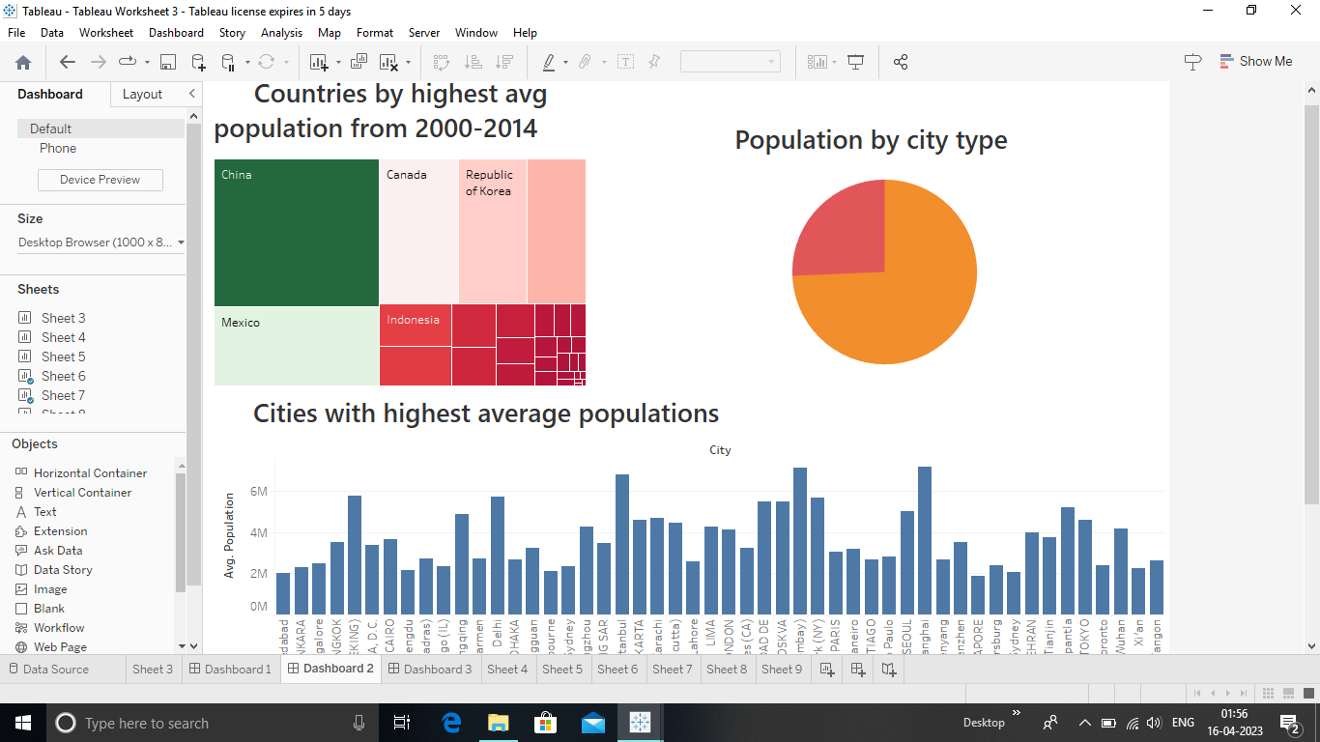



Story:

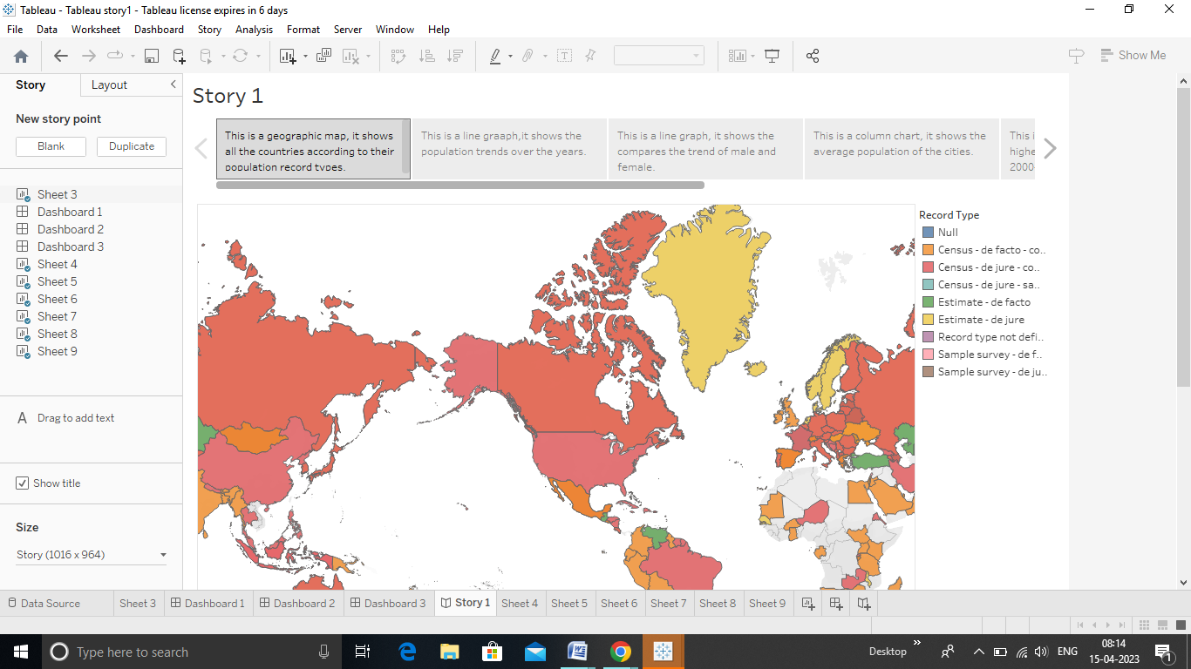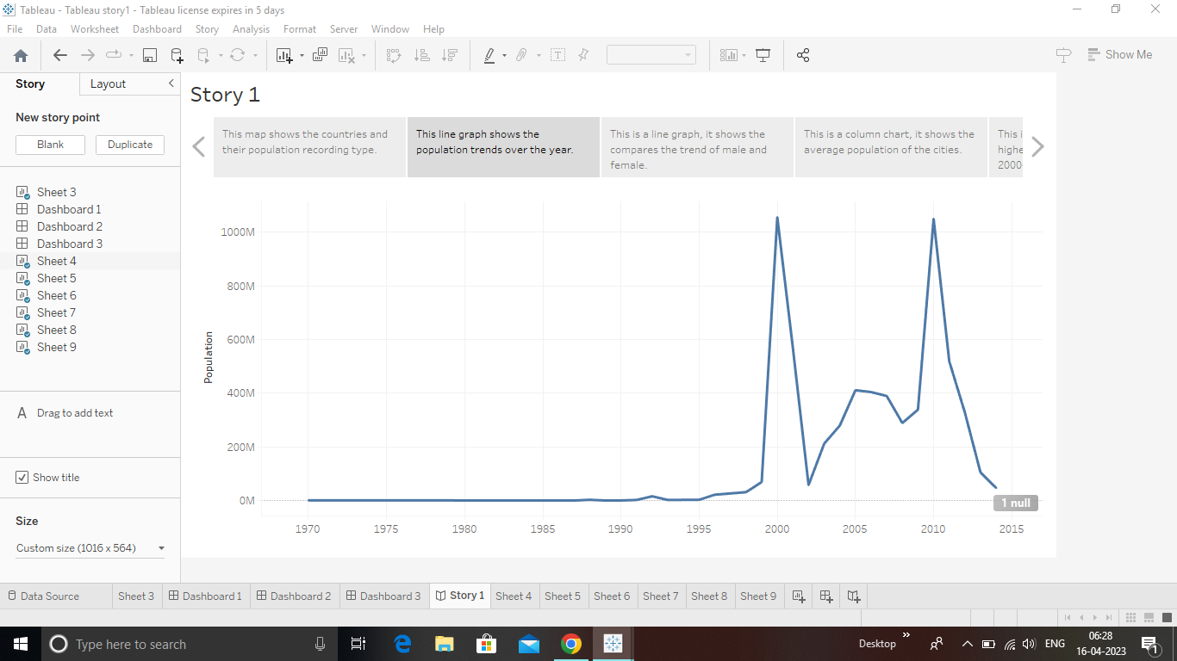

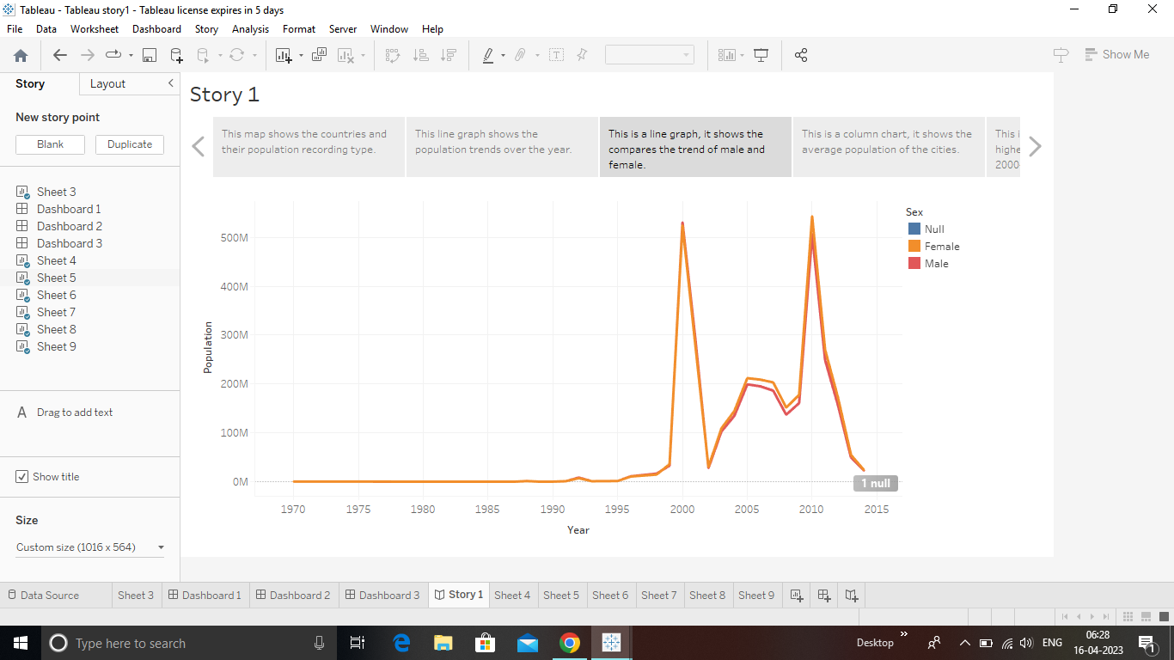

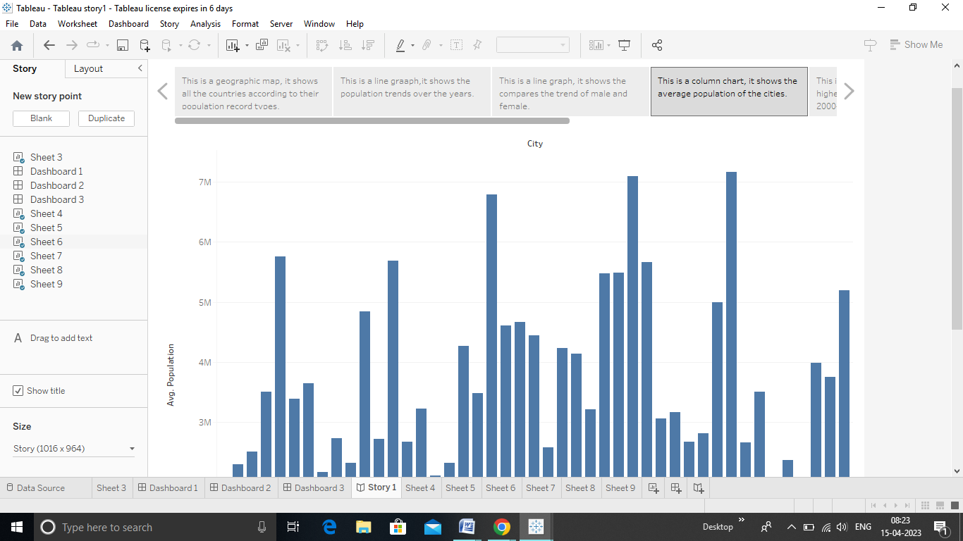

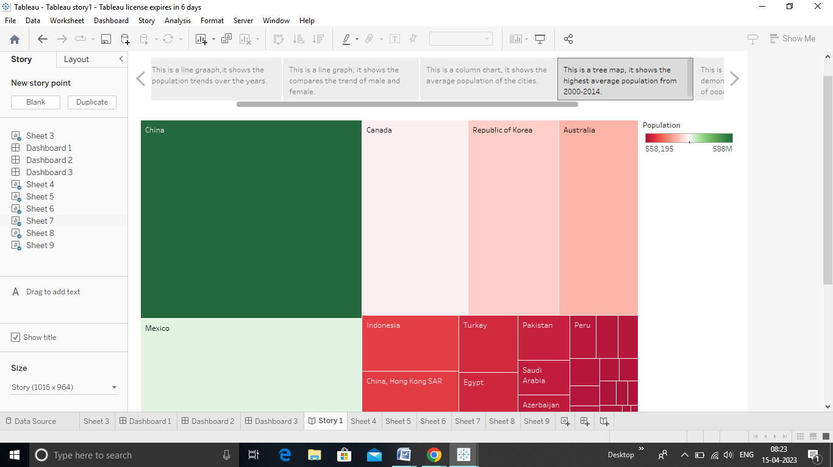

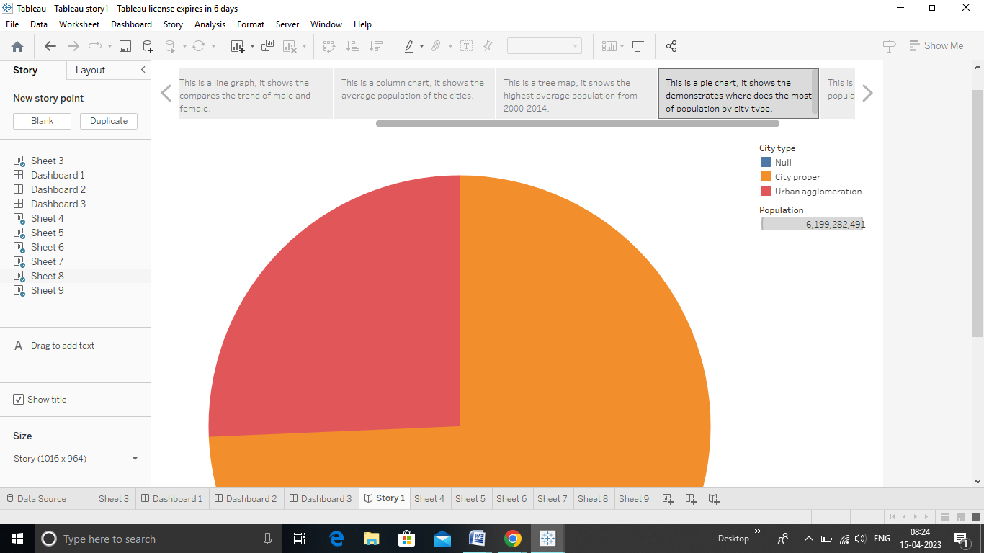

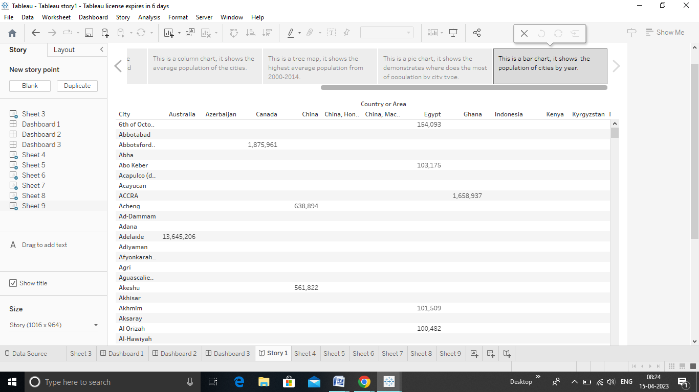

# Advantages and Disadvantages of the project:

Advantages

* Reliable regional population forecasting can provide important information for urban planning especially for decision support in regional planning.
* Basically,the analysis of regional population forecasting can be applied to estimate the demand of land for residents ,industries,public facilities ,and so on.

**Disadvantages**

* The disadvantages pertaining to forecasting include the following:Forecasts are never completely accurate forecasts are never 100% and it is almost impossible to predict the future with certainty.
* Even if you have a great process in place and forecasting experts on your payroll,your forecasts will never be spot on

# Applications

* Population forecasting is method to predict/forecast the future population of an area.
* Usually,the population at the design period of water supply systems is predicted to find the water demand at the time,as the systems are required to fulfill their purpose till the end of the design period.

# Conclusion:

* It cannot be over-emphasized that there are may verified factors influencing birth rates,migrations,and to lesser degree,death rates.
* Unfortunately,much of the research necessary to isolate these various factors and to appraise their effect remains to done.
* The planner in forecasting future population for his area may seek the aid of demographer especially trained in the technical study of population.

# Future scope:

* The world populations continues to grow,but the pace of growth is slowing down.
* The world’s populations is projected to reach 8 billion on 15 November 2022 in 2030,9.1billion in 2050 and 10.4 billion in 2100.
* The population of a country or area grows or declines through the interaction of three demographic factors:fertility,mortality,and migration.